DRAWINGS

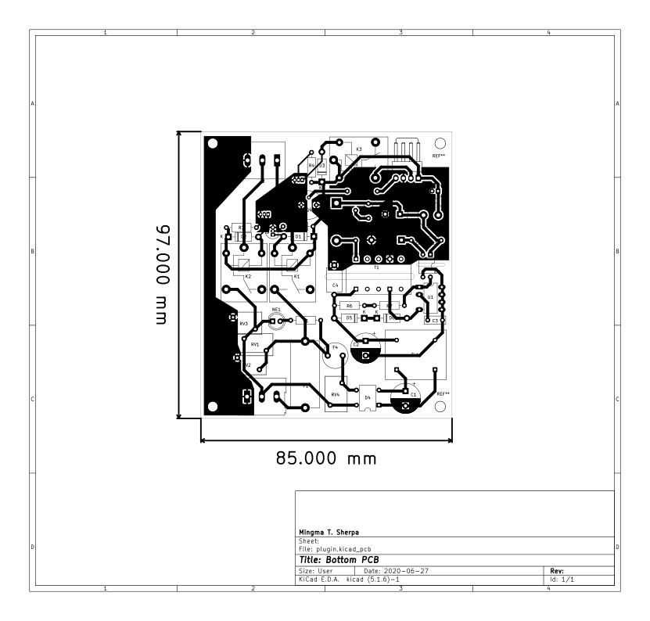
Fig 1.1: Bottom layer PCB layout

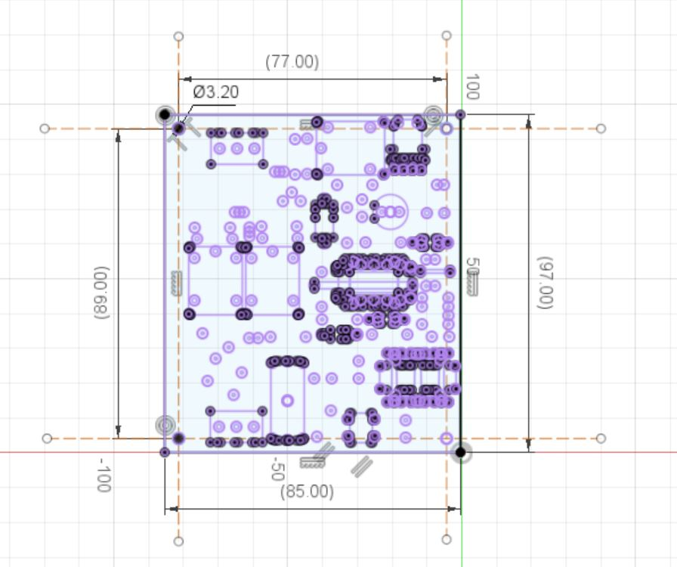
Fig 1.2: Bottom layer PCB dimensions

Above figures includes dimensions of the board along with edge cuts and drill holes. The drill holes are made compatible for M3 screws.

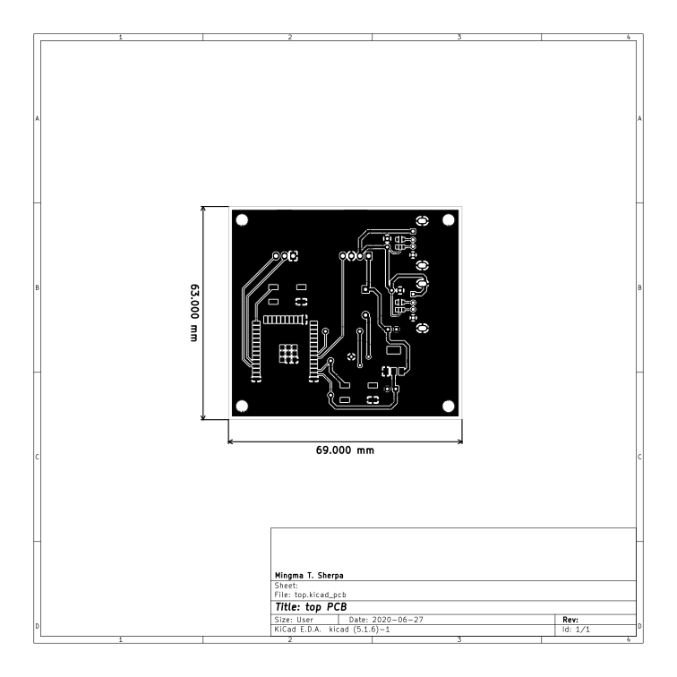
Fig 2.1: Top layer PCB layout

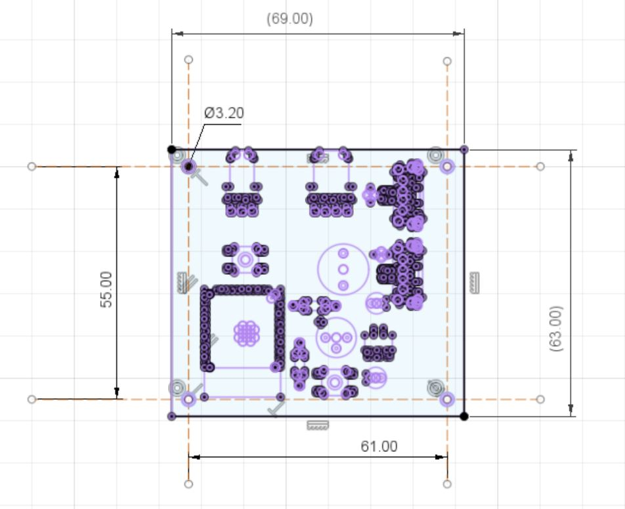
Fig 2.2: Top layer PCB dimensions

Above figures includes the dimensions of the board with all necessary masks (similar in Fig 1). The screw used are the M3 standard as in Bottom layer PCB.

